A look into chess notation used here

https://en.wikipedia.org/wiki/Forsyth%E2%80%93Edwards_Notation

Stockfish exe supports command line arguments, obviously.

From windows>R>cmd.exe if you don’t know where the command line is

C:\Users\Sayeed>stockfish.exe

The exe can be used from here just as you used the exe directly.

*Input🡺* *quit*

This will close the exe file.

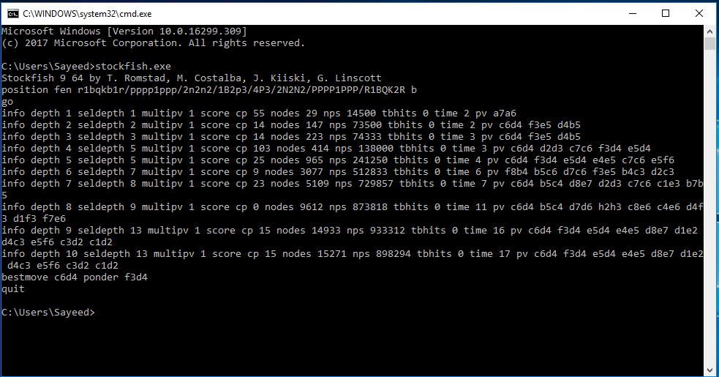

The command line arguments are also available to the exe, but as far as I have found out, the program quits as soon as you have entered a command, so you cant actually get it to take more commands. So I guess command line wont work this way

I found that Matlab command window can directly use exe files too, the same way as command lines

*Input 🡺 >> system("D:\stockfish.exe")*

And works the same way as the command line.

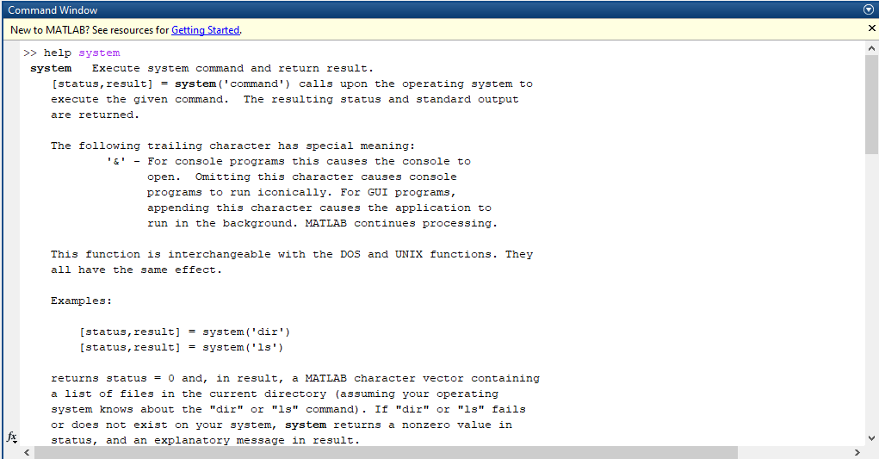

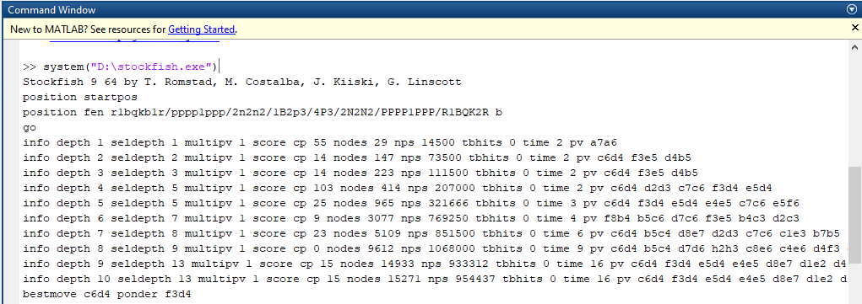

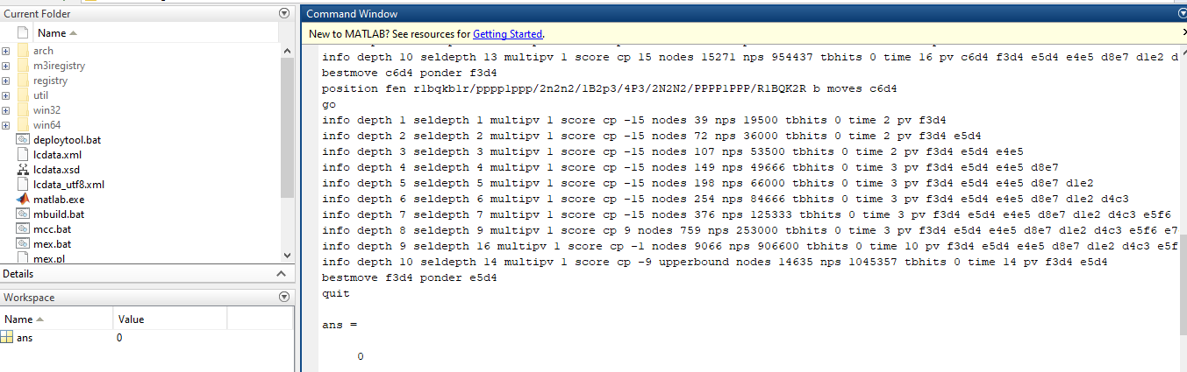

See how in the last image it returns a zero, meaning that we still haven’t managed to get any return values from the stockfish.exe file. Maybe matlab has some function that can extract and give input to the exe file while working on a script.

Now I have to look into documentation for the system() function. Also I have no clue how matlab processes string data, so documentation for string too.

